OZONE Widget Framework
Administrator’s Guide
September 1, 2015

Publication/Revision History
Release | Date
Revised – OWF 7.17.0 | September 1, 2015

Contents
1 Introduction 1
1.1 Objectives 1
1.2 Document Scope 1
1.3 OWF Purpose 1
1.4 Supported Browsers 1
1.5 Related Documents 2
2 Administrator Tools 3
2.1 User Menu 3
2.2 Administrative Managers 4
2.2.1 Manager Panel 4
2.2.1.1 Management Buttons: Create/Delete 5
2.2.1.2 Management Buttons: Edit 6
2.2.2 Administrative Managers—Search 10
2.2.3 Administrative Managers—Pagination 10
2.3 Configuration Console 10
2.3.1 Auditing 12
2.3.2 User Account Settings 12
2.3.3 Branding 13
2.3.3.1 Implementing a Custom Banner 14
2.3.4 Notifications 15
2.3.5 Store 15
3 Default Content 17
4 Creating and Editing User Content 19
4.1 Creating Users 19
4.1.1 Adding Application Components to a User Profile 20
4.1.2 Adding Users to an Application Component 20
4.1.3 Editing User Properties 21
4.1.4 User Preferences 21
4.2 Creating Applications 23
4.2.1 Editing an Application 24
4.2.2 Assign To Me 25
4.3 Creating Application Components 25
4.3.1 Creating Application Component Intents 26
4.3.2 Application Component Descriptor URL 27
4.3.3 Editing Existing Application Component Content 28
4.3.3.1 Updating and Editing Application Component Descriptor Data 28
4.3.3.2 Editing Application Component Intents 28
4.3.4 Exporting Application Components 29
4.4 Creating Groups 30
4.5 Grouping Application Components 30
4.5.1 Adding Application Components to a Group 30
4.6 Connecting to the Store 31
4.6.1 Edit a Store 32
4.6.2 Required Listings 32
Appendix A Known Issues A-1
A.1 Browser Issues A-1
A.2 User Interface Issues A-1
Tables
Table 1: Tested Browsers 1
Table 2: Related Documents 2
Table 3: Edit Button and Editor Application Component Fields 7
Figures
Figure 1: Drop-Down User Menu - Administration 3
Figure 2: Administration Tools 3
Figure 3: Users Manager Panel 4
Figure 4: App Components Tab on the User Editor 6
Figure 5: Pagination Toolbar on Managers 10
Figure 6: Administration App 11
Figure 7: Configuration Console 11
Figure 8: Notifications 15
Figure 9: Default OWF Users Group 17
Figure 10: User Dialog/DEFAULT_USER 18
Figure 11: User Editor - Groups Tab and Groups Editor - Users Tab 19
Figure 12: Preferences Tab 21
Figure 13: Preferences Dialog 22
Figure 14: Store Configuration Wizard 31
Figure 15: Store Button on OZONE Toolbar 32
Figure 16: Required Application Component Identifiers 33

- Introduction
  - Objectives
This guide covers topics relevant to administering the OZONE Widget Framework (OWF).
  - Document Scope
This guide is intended for administrators of an OWF instance. An administrator is, for the purpose of this guide, defined as someone who maintains the OWF application and handles user and application component settings. In this document, the term “Store” refers to OZONE Marketplace (OMP). Both applications share features described in this guide and both may be configured to OWF.
  - OWF Purpose
OWF is a set of tools, generally delivered in the OWF Bundle. When deployed, OWF is used for organizing and displaying Web applications (application components) in a single browser window known as an OZONE Application.
  - Supported Browsers
OWF supports Internet Explorer 7 and higher and Firefox 17 and higher. OWF is tested against the following browsers:
Table 1: Tested Browsers
Browsers | Versions
Internet Explorer | 7 & 9
Firefox | 17
Chrome | 33

  - Related Documents
Table 2: Related Documents
Document | Purpose
User’s Guide | Understanding the OWF user interface; adding, deleting, modifying applications and using application component intents; accessing and using the Store; creating, deleting, adding, switching, modifying applications; defining accessibility features such as high-contrast themes
Administrator’s Guide | Understanding administrative tools: adding, deleting, and editing app components, users, groups, applications and pages; creating default content for users, groups and group dashboards
Developer’s Guide | Creating applications and integrating existing applications into OWF; application component upgrade instructions; walkthroughs for creating application components; adding the following features to application components: intents, descriptor URLs, preference API; logging and launching API
Configuration Guide | Overview of basic architecture and security; OWF installation instructions; instructions for modifying default settings; database set up and logging guidance; framework and theme customization instructions; OWF upgrade instructions; directions for adding and deleting help content
Quick Start Guide | Walkthrough of basic OWF functions such as using OZONE Applications; instructions for setting up a local instance of OWF, unpacking the OWF Bundle and installing security certificates; Truststore/Keystore changes
- Administrator Tools
  - User Menu
The User Menu is a drop-down feature located on the right-side of the OWF toolbar. All users have access to certain OWF Options described in the OWF User’s Guide (User Profile, Themes, About and Sign Out). OWF administrators have access to the Administration OWF Option. Clicking Administration (highlighted below in Figure 1) opens the Administrator Tools (Figure 2).
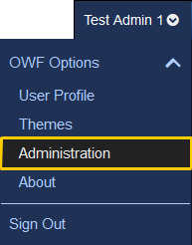
Figure 1: Drop-Down User Menu - Administration
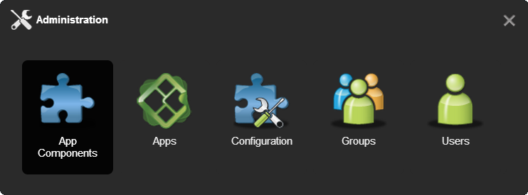
Figure 2: Administration Tools
Administration Tools allow an administrator to manage applications, application component, users, groups and system configurations using the Apps, App Components, Users, Groups and Configuration managers respectively. Information on common buttons and functions found in the Apps, App Components, Users and Groups managers is in section 2.2 : Administrative Managers. The Configuration manager allows administrators to change select OWF configuration settings from within the user interface. More information on the Configuration manager is in section 2.3 Configuration Console.
  - Administrative Managers
The administration managers are used to create, edit and delete users, groups, applications and application components as well as configure system-wide information. While each manager has specific fields that relate to the manager’s specific purpose, some of the functions operate identically. For example, the search feature in the User Manager functions exactly like the search feature in the App Manager. Accordingly, search is explained only once in this section.
Also, this document no longer contains definitions regarding basic information that general users should understand. If a topic can be easily defined by Google, it has been removed from this guide. The following section offers a general overview of the administrative managers and their use.
The manager information is broken into sub-sections:
- Panel
- Management buttons
- Search bar and pagination toolbar
    - Manager Panel
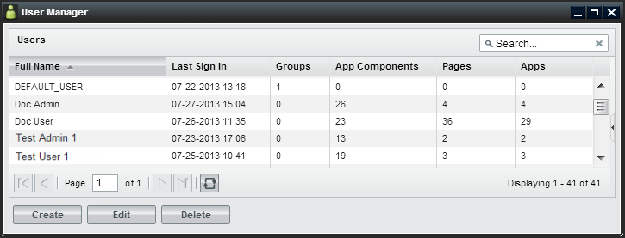
Figure 3: Users Manager Panel
The users, applications, application components and group managers open to similar panel views. The panel view described in this section applies to all four managers.
The Panel View:
- Allows the user to create, edit, delete or view an entry.
- Displays the number of users/groups/applications/pages/application components associated with the specific entry.
Note: When viewing the application component count, only the application components that are assigned directly to a user appear in the overall count. Application components associated through groups will NOT appear in the application component count.
- Offers a view of the first 50 results in alphabetical order. Additional results can be viewed using the pagination as described in section 2.2.3 : Administrative Managers—Pagination. To reduce the number of displayed results: Use the search bar, described in section 2.2.2 : Administrative Managers—Search.
From the panel, an administrator can:
- Sort - Most of the columns in the panel can be sorted in ascending or descending order by clicking on the triangle to the right of the column header and selecting a sorting option.
- Hide/Show columns - Columns can be hidden or shown by hovering over a column header, clicking the triangle that will appear, hovering over the columns menu option, and un-checking the columns to be hidden.
- Reorder columns - Columns can be reordered by clicking (and holding) a column header down and then dragging it to the desired position.
- Multiple selection - Entries can be selected for bulk operations by holding down the CTRL button while clicking multiple entries. The delete, edit, activate and deactivate buttons will perform bulk operations on all selected entries.
- View the information panel - To display more information about the entry, single-click the row to open the information panel on the right.
      - Management Buttons: Create/Delete
Administrators use the managers to create and delete users, groups and application components. Differences between the managers are referenced in sub-bullets.
- Opens the manager’s editor. From the editor, an administrator can create a new user/group/application component (depending on which editor the administrator opens) and assign related data to the new entry.
  - When creating a new entry, only the Properties tab will be active until the administrator saves the user/group/application component via the Apply button.
  - Administrators cannot create an Application using the App Manager and editor. From the App Manager, administrators can only edit and delete Applications using the App Manager. To create an application, open My Apps from the toolbar.
- Deletes selected entries. Some user/group/application/application component rules apply:
  - Deleting a group does not delete the users or application components assigned to the group. It only deletes the pairing of users with application components in the group.
  - Deleting an application removes it from the users and groups. Pages and application components associated with the application will also be deleted.
  - Deleting an application component removes it from a user’s App Components Menu as well as the groups and applications to which it was assigned.
      - Management Buttons: Edit
- Clicking Edit on any administrative manager will open the respective user/group/application/application component editor, allowing an administrator to edit the entry.
Note: If an administrator starts a manager in a fit pane, its editor will open in the first available empty pane. If not panes are available, it will “float” on top of the application. Additional application layout information is found in the OWF User’s Guide.
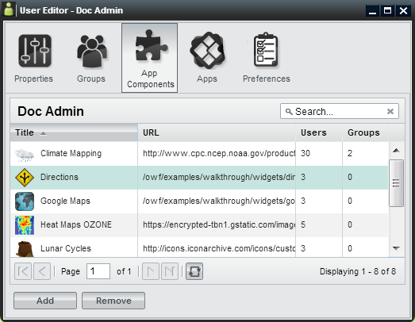
Figure 4: App Components Tab on the User Editor
From the editor, administrators can create, edit and delete data assigned to users/group/applications/application components. The following table alphabetically lists editable fields found in the managers and editors. Split Edit button features, located in the managers, are also listed. The last column of the table describes the location of each field.
Table 3: Edit Button and Editor Application Component Fields
Field | Purpose | Location
Activate/Deactivate | Users in active groups have full access to their group-assigned app components. Users in a deactivated group will not have access to any of the app components which are assigned to them via the deactivated group. When a group becomes deactivated it will appear gray.  Note: If a user is in Group A and Group B and each group has App Component 1 assigned to it, the user will still have access to App Component 1 if Group A is deactivated and Group B is activated. Additionally, if the user has App Component access outside of a group’s distribution, the user will not lose access to the App Component, even if they lose group access. | Group Manager (under the split Edit button);  “Active” checkbox in the Group Editor, Properties Tab
App Component Type | A drop-down menu that determines where the application component may be launched.  - Only standard application components appear in the App Component Menu.  - Administration components will appear under the Administration link available in the drop-down User Menu.  - Application components set to type “Store” will appear under the Store button on the toolbar.  - Metric App Components are accessible through the Metrics link in the drop-down User Menu.  - Setting an app component to “fullscreen” in OWF does nothing to the component. This field is used by the Store to send Web Apps to OWF as separate applications.  Note: Instructions explaining how to associate OWF with a Metrics Service are found in the OWF Configuration Guide. | App Components Editor, Properties Tab
Assign To Me | This button allows an administrator to claim ownership of an application. Only an application owner can share an application with the Store or with other users if there is no Store. If the application owner is removed from the system, the application owner defaults to “System”. | App Manager
Background | Some application components do not have user interfaces. These application components are often used to cache or log data on behalf of other components. If an app component is set to run in the background, it will not appear in the application. Users can close background components by using the App Component Switcher (activated with Alt + Shift + Q). | App Component Editor, Properties Tab
Container Icon URL | Defines the location of the icon which appears in app component chrome at 16x16 pixels. | App Component Editor, Properties Tab
Display Name | The group name which will appear in grids and tables throughout administrator views. | Group Editor, Properties Tab
GUID | A unique 32-character alpha-numeric code for a particular named app component. If “App Component A” is launched 5 times, all 5 app components will share the same GUID property. | All Editors, Properties Tab
Height | Defines the launch height of the application component in pixels. Up and down arrows to the right of the field can be used to modify the overall height. Only desktop panes are affected by this property. | App Component Editor, Properties Tab
Intents | Application component intents build on OWF’s publish/subscribe functionality by allowing users to choose the application component that will receive its data. Intents explain the intention for the app component. This binding capability enables two application components to enhance each other’s functionality. | App Component Editor, Intents Tab
Medium Icon URL | Defines the URL of the icon which appears in the App Components Menu, provided the “visible” menu flag (mentioned below) is checked. | App Components Editor, Properties Tab
Mobile Ready | Suggests that a listing can run on a mobile device. This setting only applies to MONO instances. MONO is a mobile project using the Store and OWF. If OWF is running in a MONO instance, only Mobile Ready listings will appear. | App Components Editor, Properties Tab
Remove | Separates the selected user/group/application/application component from the selected entry. This does not delete the user/group/application/application component from the system. It only removes the assignment to the selected entry. | All Editors
Singleton | Designates whether an application component can only have one instance opened per application page. | App Component Editor, Properties Tab
Small Icon URL | Defines the location of the icon which appears as a favicon in the corner of the app component when it is minimized, provided the “visible” menu flag (mentioned below) is checked. | App Components Editor, Properties Tab
Universal Name | A value that can be used as an application component’s global identifier across all instances of OWF. This differs from an application component GUID which is unique to a specific installation. The Universal Name should be decided by an App Component’s creator. | App Components Editor, Properties Tab
URL | Defines the URL of the App Component web application. This is a required field. | App Components Editor, Properties Tab
User Management | Defines whether or not the group is an automatic group, being populated and maintained by external sources. This value cannot be modified once the group has been created. | Group Editor, Properties Tab
Version | Displays the version number of the App Component. This is completely user-driven and is for informational purposes. | App Components Editor, Properties Tab
Visible | Dictates whether a listing will show in a user’s App Component Menu. This cannot be overridden by the user. | App Components Editor, Properties Tab
Width | Defines the launch width of the application component in pixels. Up and down arrows to the right of the field can be used to modify the overall width. Only Desktop panes are affected by this property. | App Components Editor, Properties Tab
    - Administrative Managers—Search
- Reduces the entries displayed in the panel to entries containing the specified word or characters entered in the search bar. Press Enter or click the magnifying glass to apply the search and display the filtered results in the panel. Click the X button to clear the filter and display all entries in the panel.
Note: This is a full-text search and it is NOT case-sensitive.
    - Administrative Managers—Pagination
Figure 5: Pagination Toolbar on Managers
-  - Navigates between pages of results displayed in the search results panel.
- - Refreshes the results in the search results panel, maintaining the current filtering and sorting options.
- 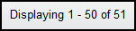 - Displays the number of results being shown against the overall total in the system.
  - Configuration Console
Administrators have the ability to change OWF configurations quickly and without the need to restart the system. Using the Configuration Console, change settings for auditing records, managing user accounts, customizing certain branding features, and configuring notifications and store associations through the user interface. Use the following instructions to locate the Configuration console:
- Click the Administration link in the drop-down User Menu (Figure 1).
- This opens the Administration Tools (Figure 2). Select Configuration to open the Configuration Console.
In addition, all administrator managers (including the Configuration Console) are available in the Administration application, as app pages, accessible through the My Apps menu, seen below. Click Configuration to open the Configuration Console.
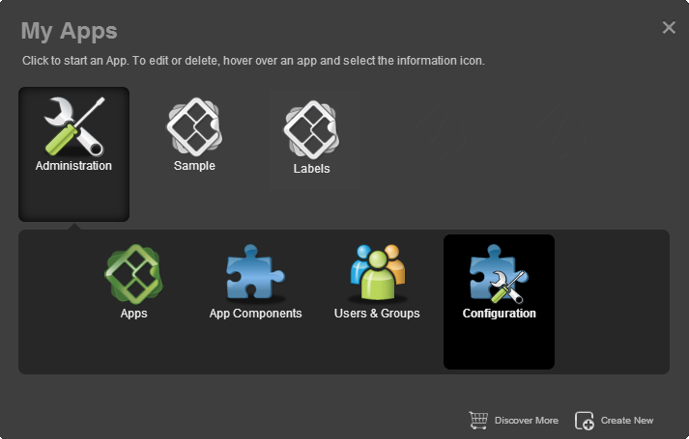
Figure 6: Administration App
The Configuration Console has five sections accessible to administrators: Auditing, User Account Settings, Branding, Notifications and Store. The following sections describe each option:
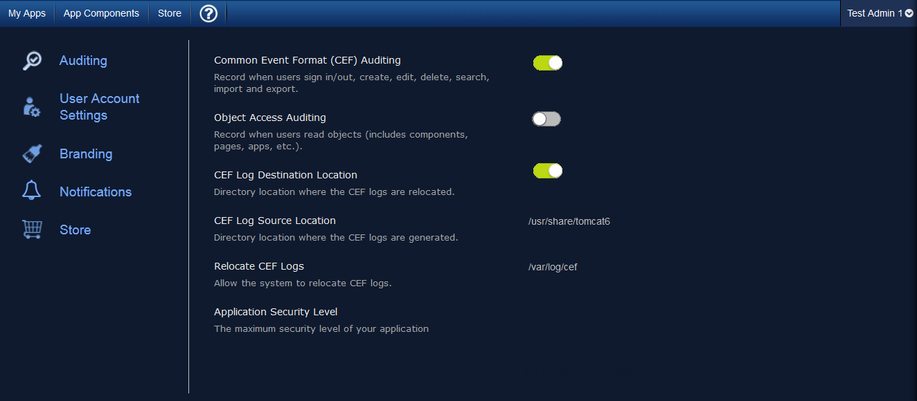
Figure 7: Configuration Console
    - Auditing
The Auditing configuration allows administrators to activate Common Event Format (CEF) logging and specify aspects of this logging feature. To access this setting, click Auditing on the left-hand navigation of the Configuration Console (Figure 7). Each Auditing option is described below:
- Common Event Format (CEF) Auditing – Enabled by default, this records user actions such as sign in/out and database modifications (create, edit, delete, search, import and export). Click OFF to disable.
Note: For more information about CEF Auditing, see the OWF Configuration Guide.
- Object Access Auditing – Click ON to enable; this records CEF audit logs for all database reads. This includes most user actions such as viewing an application, clicking a button, etc.
- CEF Log Destination Location – The directory location where the CEF logs will be relocated if the “Relocated CEF Logs” option is enabled..
Note: Developers may need to grant permission for the application container to write to this location.
- CEF Log Source Location – The directory location where the CEF logs are generated. The default location is the Tomcat directory: /usr/share/tomcat6
- Relocate CEF Logs – Enabled by default, this feature allows the system to relocate the CEF logs from their original location to a different location. Click OFF to disable.
- Application Security Level – The security level of the CEF logs.
    - User Account Settings
The User Account Settings configuration allows administrators to modify global user account settings. Specifically, these settings control the number of active OWF sessions allowed per user and sets the parameters needed to disable a user account. Access these configurations by clicking User Account Settings from the left panel of the Configuration Console (Figure 7). Each User Account Setting is explained below:
- Session Control
  - Session Control – When set to ON, allows the administrator to set a maximum number of concurrent, active OWF sessions a user can have.
  - Maximum OWF Sessions per User – The maximum number of active OWF sessions a single user is permitted to have at one time.
If the Session Control function is turned on and the user exceeds the number of maximum open OWF sessions, the oldest session will be disabled. For example, if the maximum number of active OWF sessions is three and a user opens up four sessions of OWF, the first session the user opened will no longer be active.
- Inactive Accounts
  - Disable Inactive Accounts – A toggle switch to enable user accounts to be disabled after a period of inactivity.
  - Set Inactivity Period – Click on the text field and type in the number of days that need to elapse since a user last signed in before the account is disabled.
When a user’s account is disabled:
  - Application ownership for the disabled account transitions to “System” so that any application the disabled user created will not be removed from the instance of OWF.
  - The disabled user’s “last sign in” will be removed. Also removed are the user’s preferences and any references to that user.
  - If a user signs in after their account is disabled, any of their previous application components, preferences, etc. will not be recoverable.
Note: The Disable Inactive Accounts only removes user data within the OWF application. It does not affect the user’s ability to log back into the application. Authentication decisions are handled by the customizable OWF Security Plugin. See the OWF Configuration Guide for more details.
    - Branding
The Branding Configuration setting allows administrators to customize the appearance of the OWF background as well as the appearance and content of the OWF header and footer. This feature is accessible by click Branding from the left-side navigation of the Configuration Console (Figure 7). Each Branding option is described below:
- Custom Background
  - Custom Background URL – File name (including extension and location) for the background image that will display on the OWF home screen. For example: https://example.com/image/yourLogo.png
- Custom Header and Footer
  - Custom Header URL – File name (including extension and location in the system) for a custom header that appears above the OWF toolbar; the URL must be valid for it to appear.
  - Custom Header Height –Height of the custom header (the height must be greater than zero and less than 150 pixels).
  - Custom Footer URL – File name (including extension and location in the system) for the footer that appears about the bottom of the OWF webtop; the URL must be valid for it to appear. If it is not, a black box displays in its place.
  - Custom Footer Height – Height of the custom footer (the height must be greater than zero and less than 150 pixels).
  - Custom Header/Footer CSS Imports – URL(s) of CSS files needed by the custom header and footer.
  - Custom Header/Footer JavaScript Imports – URL(s) of JavaScript files needed by the custom header and footer.
  - FreeText Message – This text displays anywhere a user can enter text.
      - Implementing a Custom Banner
OWF is bundled with a custom header/footer plugin that provides the necessary functionality to display custom banners at the top and bottom of each page. To use this custom plugin:
- Sign in to the application as an administrator.
- From the drop-down User Menu, click Administration then, select Configuration.
- Click Branding from the left-navigation panel.
- Enter the following data in the corresponding fields:
  - Custom Header URL
  - Add a custom header height.
  - Custom Footer URL
  - Add a custom footer height.
  - Path to Custom Header/Footer CSS Imports
    - Notifications
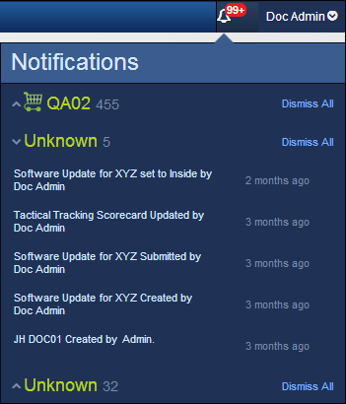
Figure 8: Notifications
Note: The Notifications feature is a prototype and is not fully functional.
The OWF Notifications system connects an OWF instance to an XMPP server through which it can receive information about App Components. This feature was originally designed to be used by administrators to monitor the changelogs’ of Store listings, but may also be used to allow any App components to communicate with OWF users. App components that connect to this XMPP server can use it to publish notification messages for consumption by OWF users. Messages published to the chat room must follow a specific format that designates both the message content and the OWF usernames of the intended recipient users. The OWF server will then receive the messages from the chat room and distribute them to individual users.
If notifications are enabled, administrators will see a persistent list of changes regarding all listings. Right now, notifications tell administrators about changes that occurred since they last viewed the system including: when a listing is submitted, rejected, modified, created, approved, enabled, disabled, required, set to inside/outside or the compliance section (scorecard) changes.
To configure OWF to use notifications, create a chat room on an XMPP server and enable notifications in the OwfConfig.groovy, find instructions in the OWF Configuration Guide.
    - Store
The Store configuration provides an easy-to-use wizard to walk administrators through the process of connecting OWF to a Store. Admins can connect their OWF to one or more Stores. A new Store connection will not replace existing Stores connections. Instead, when users click the Store button in the OZONE Toolbar, a prompt appears asking them to select from multiple Stores. Access the Store configuration by clicking Store from the left-side navigation panel on the Configuration console (Figure 7). Each option is described below:
- – The first button that appears on the Store configuration page. Click this button to start the wizard and add a Store.
- Store URL –Enter the location for the Store that will be connected to OZONE. This URL is used by OWF to gather details about the Store including name and icon.
  - Store Name – Name that identifies the Store to users in OWF.
  - Icon – Image that identifies the Store to users in OWF.
-  Edit – Appears on the right of a Store icon when hovering over an added Store entry on the Store configuration page. Click it to change the Store’s URL, icon or name.
-  Delete – When hovering over a Store entry, a trashcan icon appears to the right of the selection. Click this to delete the Store connection.
After a Store has been configured, administrators can edit, add or delete Store settings from the Store configuration page. Instructions for connecting OWF to a Store are found in section 4.6 : Connecting to the Store.
- Default Content
OWF ships with a default user profile and default user groups. Administrators can use the default profile and default group to add applications and application components to a user or several users’ instance of OWF.
OWF Users – A default group that ships with OWF. Every user is automatically assigned to it.
Like an OWF group, Apps and App Components assigned to OWF Users are available to all users in the group. Since all users are automatically members of the OWF Users group, this group can be used to assign Apps and App Components to all users.
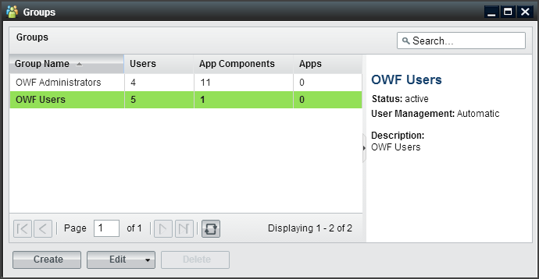
Figure 9: Default OWF Users Group
OWF Administrators - A default group that ships with OWF. Every administrator is assigned to this group.
Like any OWF group, Apps and App Components assigned to OWF Administrators are available to all group members. Since all administrators are automatically members of this group, it can be used to assign Apps and App Components to all administrators. Users cannot be assigned to this group and administrators cannot delete the default Editors and Managers populating this group.
Note: The OWF Administrators and OWF Users groups cannot be deleted, renamed or deactivated. In the event that either group is single-selected in the Groups manager, the Delete button will be grayed out. If either (or both) groups are selected along with other manual groups, the Delete button will be active. However, upon clicking Delete, only the manual groups will be removed from the system. Additionally, the Users tab in the Group Editor is disabled for these groups. Any user with access to OWF will receive OWF Users group resources. Any user reported to have an administrative role by the underlying security system will receive OWF Administrators group resources. If these groups are removed from the OWF database, restarting the OWF server will recreate them with no custom applications or application components.
DEFAULT_USER – A default user profile that ships with OWF. The DEFAULT_USER data will automatically be assigned to every new user of a particular OWF installation.
When a new user enters OWF for the first time, the DEFAULT_USER data will be applied and copied to that user’s profile. After the initial login, any changes that the user makes will only impact their data from that point on. The DEFAULT_USER data remains unchanged and will continue to be applied to all new users.
Note: If an administrator makes changes to the DEFAULT_USER data set, it will only impact the users who log in for the first time, following the change. Any users who received the data prior to the change will not be affected.
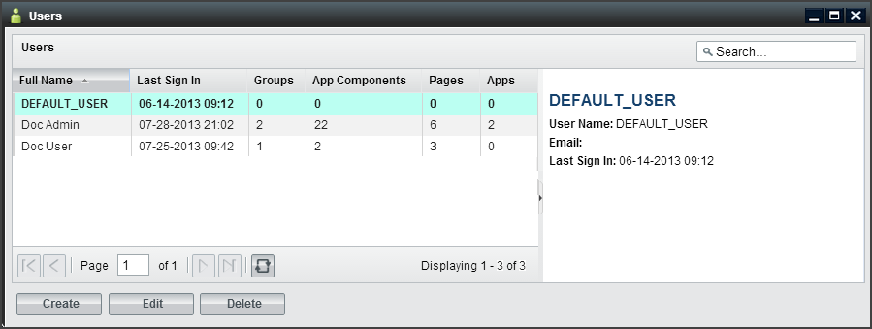
Figure 10: User Dialog/DEFAULT_USER

- Creating and Editing User Content
Creating and editing users, groups, applications and application components is explained in this section. This includes adding groups/applications/application components to user profiles through the User Editor (left image, Figure 11). OWF also allows administrators to add users to groups/application/application components through the Users tab on the respective Editors (right image, Figure 11). These examples are described in sections 4.1.1 : Adding Application Components to a User Profile and 4.1.2 : Adding Users to an Application Component.
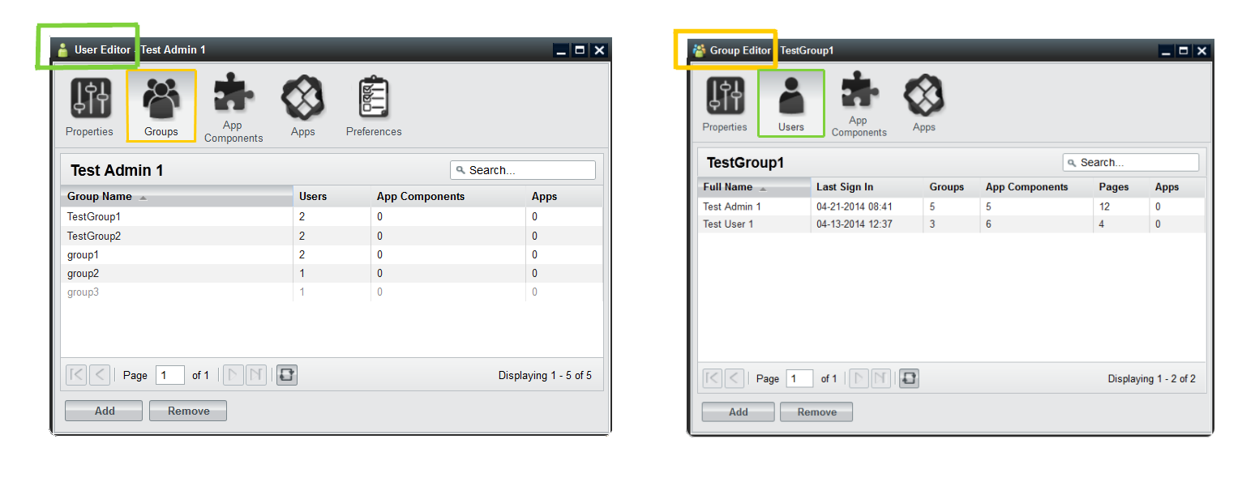
Figure 11: User Editor - Groups Tab and Groups Editor - Users Tab
  - Creating Users
Administrators have the ability to create new user profiles, edit existing user information and add groups/applications/application components to user profiles.
To create a new user profile:
- Click the Administration link in the drop-down User Menu.
- Choose the Users button to open the User Manager.
- Click on the Create button, opening the User Editor.
- Enter the user’s information. Mandatory fields (User Name and Full Name) are denoted with a red asterisk. More information about these fields is found in Table 3: Edit Button and Editor Application Component Fields.
- When complete, click Apply. This will save the user and activate the additional tabs in the User Editor.
- To add groups, applications or application components to a user account, proceed to the instructions in sections 4.1.1 : Adding Application Components to a User Profile or 4.1.2 : Adding Users to an Application Component.
Note: Administrators do not create or maintain user passwords in the OWF interface. Security and authentication are addressed in the OWF Configuration Guide.
    - Adding Application Components to a User Profile
The following instructions describe how to add application components to a user account using the App Components tab found in the User Manager. Administrators can follow this basic formula to add groups, application and application components to user profiles via the Groups, Applications and App Components tabs in the User Editor.
To add application components to a user’s account:
- Click the Administration link in the drop-down User Menu.
- Click the Users button to open the User Manager.
- From the manager, select a User. Then, click Edit to open the User Editor.
- Click the App Components tab at the top of the editor. Application components that are already associated with the user will display in the window.
- To add application components, click the Add button. A modal window will display all application components available to that user. Select an application component, then, click the OK button. The application component is automatically added to the list of components on the user’s App Component tab.
    - Adding Users to an Application Component
Another way to give users access to application components is to add users to the application component’s profile via the App Component Editor. Again, administrators can use this general procedure to add users to groups and applications through the Users tabs in the respective editors. When completed, close the editor window and the data will be updated automatically to the user profile.
To add users to application component profiles:
- Click the Administration link in the drop-down User Menu.
- Click the App Components button to open the App Component Manager.
- From the manager, select an application component. Then, click Edit to open the App Component Editor.
- Click the Users tab at the top of the editor. Users that are already associated with the application component will display in the window.
- To add users, click the Add button. A modal window will display all users available to that application component. Select a user, then, click the OK button. The user is automatically added to the list of users on the application component’s Users tab and the application component is available to the user’s instance of OWF.
    - Editing User Properties
To edit existing user content:
- Click the Administration link in the drop-down User Menu.
- Click Users to open the User Manager.
- From the manager, select a user account to update and click Edit.
- Update data on the Properties tab and click Apply. Update each field, then click Apply. For definitions of less common fields, see section Table 3: Edit Button and Editor Application Component Fields.
This procedure is also used when editing the properties of groups, applications and application components. To edit the content, click the Administration link in the drop-down User Menu and click on the respective manager and click Edit to open up the editor. Make changes in the Properties tab and click Apply.
    - User Preferences
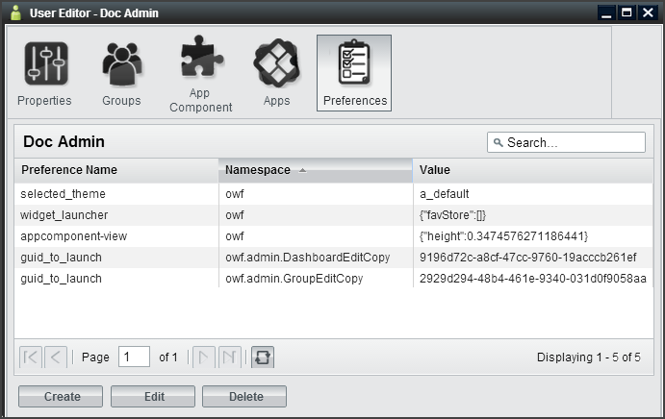
Figure 12: Preferences Tab
Application components use preferences to store data. Preference date includes the application component’s location on the screen, instructions to open it, etc. A preference value can be created and saved at any time by a running app component. Once that preference is saved to the database, it will appear on the Preferences tab in the User Editor. The Preferences tab serves as a table of known preferences. From the tab, administrators can view, create, edit and delete preferences. However, from the Preferences tab, the administrator cannot configure an application component to use a preference. App Components will only use the preference they are programmed to use defined via the Preference API.
If an application component is configured to use preferences, they can be used to define component states, interaction, etc. For example, the guid_to_launch preference is an example of a preference used by the Administration Managers to know which Editor to launch. Other App Components could use this same preference as an eventing tool. For example, administrators can use this preference to make a Tracking application component open a Map application component. As seen in Figure 12: Preferences Tab, the guid_to_launch preference causes the User Manager to open a copy of the App Component Editor.
The Preferences tab includes the following fields:
- Preference Name - The preference name, along with the Namespace, make up the “key” for the preference item. The Preference Name is the name of the preference as dictated by the application component or OWF. If the application component uses preferences, OWF will add the preference name to the table on the Preference tab whenever the action that is associated with the preference is performed.
- Namespace - The namespace is the other half of the preference’s unique identifier. Generally, these identifiers will describe general functionality for an application component or set of application components. Namespace/Preference Name pairs are unique for each user.
- Value - Stored inside of the preference, values house the data that the preference uses. An example could be the actual application component GUID value that the preference will use to open an application component. This is a string value but developers can use JSON or REST URIs as the preference value.
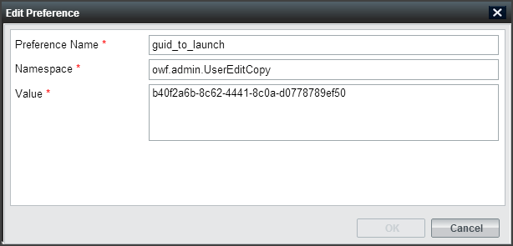
Figure 13: Preferences Dialog
  - Creating Applications
Creating an application is not an exclusive administrator function. Unlike previous versions of OWF where stacks were created by administrators in the Stacks Manager, applications are created by users and administrators using the My Apps Menu.
To create a new application:
- Click 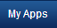 in the toolbar to open the My Apps.
- Click “Create New App” at the bottom of the screen to open the Create New App window.
- Give the application:
  - A title (required)
  - An image URL (optional) that appears in the My Apps window
  - A description (optional)
Note: The application cannot be saved without a title.
- Choose a layout for the application. Click the radio button beside the selected layout method. Layout options include:
  - Choose a template – Choose one of twelve premade layouts.
  - Copy the layout of an existing App – Clicking this causes a drop-down menu to appear below the selection title. Choose an application from this menu. The new application will adopt the layout of the selected application. However, it will not copy the app components associated with that layout.
  - Create a new layout – Opens the Application Builder allowing the user to create a new layout. More information on creating a new layout is found in the OWF User’s Guide.
- Click OK. The application will automatically start unless you selected “Create a new layout,” if that is the case instructions for the Application Builder are found in the OWF User’s Guide.
- To add application components to the App, click the App Component button on the OZONE Toolbar and select components by clicking them. If the App has more than one pane, click the pane where the component will start.
Next time the My Apps menu is opened, it will contain this app. This app belongs to the user who created it.
- When OWF is connected to a Store, administrators cannot share the application with other OWF users until the application is shared with the Store. To do this, open My Apps and click the Details button on the App, then, select Push to Store.
- When OWF is not connected to a Store, assign the application to OWF users and groups using the instructions in section 4.2.1 : Editing an Application.
- If an administrator deletes an app, the user will retain a copy of the app and the pages and components included in the app. However, they will lose the ability to restore it.
- If an administrator changed the app and its contents after it was added to a user’s instance of OWF, the current state of the app may be different than the one that originally appeared on the user’s My Apps window.
Note: Creating a new application, in effect, creates a one-page application. The application and the single page share the same title, description and icon. The layout assigned to this application applies to the single page rather than the application. Users can add additional pages, and therefore additional layouts, to this application. When more than one page is added to an application, the user has the ability to change the single page’s properties. Also each page is edited independent from other pages or the parent App.
    - Editing an Application
Only shared applications or applications added to the Store and Approved in the Store can be assigned to individual users or groups from the Application Manager. That means that a user willingly made available a copy of their application for administrators to distribute to other users. For that reason, administrators have limited editing ability for Applications. They cannot edit the App’s properties (name, layout, etc.) or App Components from the Application Manager. Those edits must occur in the actual App, for instructions see the OWF User’s Guide. From the App Manager, administrators can add or remove users and groups as described below:
- Click the Administration link in the drop-down User Menu.
- Click Apps to open the App Manager.
- From the manager, select an App and click Edit, the App Editor will start.
- From the App Editor, you’ll see:
  - A list of the App’s Components will appear for informational purposes only. To add App Components, open the actual Application and add components from the App Component Menu.
  - Groups associated with the App.
  - Users associated with the App.
- To add a group, click the Group tab and then click the Add button. A modal window will display all available groups. Select a group, then, click the OK button. The App is automatically added to the group members’ My Apps Menu.
- To add a user, click the User tab and then click the Add button. A modal window will display all available users. Select a user, then, click the OK button. The App is automatically added to the user’s My Apps Menu.
In order to assign users and groups to an application that was retrieved from the Store, two actions must occur:
- The application must be approved in the Store. If the application has not been approved in the Store, the administrator will receive a warning message when they attempt to assign the application to a user or group.
- The Store synchronization feature must be enabled and configured to connect OWF to the Store. For more information on enabling this feature, see the OWF Configuration Guide.
If OWF is not connected to a Store, the owner of the application must first allow the administrator to share the app with other users. To do this, the app owner (who can be an OWF user without administrative privileges) must open the App’s information window and click the Share button. Instructions are provided in the Ozone User’s Guide.
Note: When OWF is not connected to a Store, OWF does not require the synchronization feature to assign applications to users and groups.
    - Assign To Me
In the Application Manager, when an administrator selects an Application and clicks “Assign To Me,” the system reassigns ownership of the application to the person that clicked the button. This feature was included because an application must have an owner in order to be shared with the Store. Only an owner can push an application to the Store. If its owner is removed from the system, the “Assign To Me” button allows an administrator to claim ownership of the app. If an administrator reassigns ownership, all users in the system will retain their copies of the Application.
  - Creating Application Components
Administrators can create, edit, delete, import and export application components. There are two ways to create an application component: importing application component data with a descriptor URL or manually entering application component data. Imported application component data is editable through the App Component Editor (see 4.3.3 : Editing Existing Application Component Content).
To create an application component, the administrator must complete several mandatory fields in the App Component Editor. Information about each application component data field is found in Table 3: Edit Button and Editor Application Component Fields. For example, the App Component Type field is useful for separating application components on a user’s toolbar. Only “Standard” type application components will appear in the App Components Menu. “Administration” application components will appear when the Administration link is clicked in the drop-down User Menu. Application components set to type “Store” will appear under the Store button on the toolbar. “Metric” type application components will appear when the Metric link is clicked in the drop-down User Menu. Setting an app component to “fullscreen” in OWF does nothing to the component. This field is used by the Store to send Web apps to OWF as separate applications.
To create an application component:
- Click the Administration link in the drop-down User Menu.
- Click the App Components button to open the App Component Manager.
- From the manager, click the Create button to open the App Component Editor.
- From here, there are two ways to create application components:
  - Import a descriptor URL—Enter a descriptor URL and click Load. For more information about descriptor URLs see section 4.3.2 : Application Component Descriptor URL.
  - Manually enter data—If a descriptor URL is not available, click the “Don’t have a descriptor URL?” link and complete the required fields on the Properties tab. Remember that the application component Type will dictate the location of the application component. For more information about specific entry fields, see Table 3: Edit Button and Editor Application Component Fields.
- Click Apply. This will unlock the Users, Groups and Intents tabs on the App Component Editor. Select each tab and click the Add button to add users, groups and intents to the application component. Information about adding Intents to an app component is in section 4.3.1 : Creating Application Component Intents.
- Refresh OWF. The new application component will appear under the respective toolbar button for users to whom the component has been assigned.
    - Creating Application Component Intents
Application component intents are the instructions for carrying out an application component’s intentions. Intents comprise an Action (graph, view, edit, etc.), a Data Type (html, text, image, etc.) and a Send/Receive request. For intents to function in OWF, a developer has to code the actual function into an app component, see the OWF Developer’s Guide for instructions.
App Components coded with identical Action and Data Types can communicate with each other. For example, the New York Stock Exchange (NYSE) application component sends an intent to graph (Action) daily stock data (Data Type). The Stock Chart application component, configured and coded to receive the same intent Action and Data Type, is able to receive this request and graphs the data. The intents mechanism allows the user to select which of the available components will receive the intent. This binding capability enables the two application components to enhance each other’s functionality. Administrators can add, edit and delete application component intents, however, a developer or someone with experience using intents is more likely to perform these tasks.
Note: Find instructions about using intents in the OWF User’s Guide and instructions about creating intents in the OWF Developer’s Guide.
The Store ships with several default intents Actions and Data Types. It will NOT function as expected until a developer establishes a relationship between the intent and the app component as described in the OWF Developer’s Guide. The default intents from the Store serve as metadata used as placeholders for OWF developers to create consistent intents. After a developer establishes that relationship, the following instructions will allow administrators to add intents to an application component:
- Click the Administration link in the drop-down User Menu.
- Select App Components to open the App Component Manager.
- From the manager, select an application component and click Edit.
- Click the Intents tab. Click Create to open the Create Intent window.
- Complete the fields, required fields are marked with an asterisk.
  - Action — The Action field is the instruction the intent will make (ex. graph or view).
  - Data Type — The Data Type field indicates the data that the intent is passing from application component to application component (ex. text/html).
  - Send/Receive — This tells the application component to send or receive the application component intent.
- Click OK. The intent has been added to the application component and will be displayed in the Intents tab in the App Component Editor.
Note: It is recommended that App Components, which use Intents, provide a Descriptor file containing the Intents configurations instead of relying on administrators following the above procedure.
    - Application Component Descriptor URL
Descriptor URLs allow an administrator to create application components without entering the application component's information manually. The administrator simply enters a URL and the application component's information is automatically retrieved from a descriptor file from a Web-accessible location. Application components created with a descriptor URL are editable in the App Component Editor.
Descriptor URLs:
- Reduce the risk of typing errors when entering application component data.
- Allow several installations of OWF to easily share application component information.
- Allow component developers to specify important configuration information such as Universal Names and Intents.
    - Editing Existing Application Component Content
To edit existing application component content:
- Click the Administration link in the drop-down User Menu.
- Select App Components to open the App Component Manager.
- From the manager, select an application component and click Edit.
- Edit the application component data on the Properties tab and click Apply. For definitions of less common application component data fields, see Table 3: Edit Button and Editor Application Component Fields.
Users and groups assigned to the application component will receive the application component data changes automatically.
      - Updating and Editing Application Component Descriptor Data
Administrators can update and edit the application component descriptor data within the OWF interface. Updating the application component descriptor data retrieves the latest data in the application component’s descriptor file which is saved in a Web-accessible location. Changes made to the application component prior to the update are lost once the update is performed.
To update the application component descriptor data:
- Click the Administration link in the drop-down User Menu.
- Select App Components to open the App Component Manager.
- From the manager, select an application component and click Edit.
- Click Load. The App Component Editor will automatically refresh and display the most recent application component descriptor data.
- Click Apply.
Administrators can edit their copy of the application component descriptor data by following the steps outlined in section 4.3.3 : Editing Existing Application Component Content. Descriptor data changes are sharable after the administrator exports the application component and saves the descriptor file in a Web-accessible location. Individuals who already have access to this application component will have to update their copy of the application component’s descriptor data in order to see the application component changes in their OWF instance.
      - Editing Application Component Intents
It is recommended that a developer, or an individual experienced with using intents, edits the application component intents.
To edit application component intents:
- Click the Administration link in the drop-down User Menu.
- Select App Components to open the App Component Manager.
- From the manager, select an application component and click Edit.
- Click the Intents tab, select an intent and click Edit.
- Once changes have been made, click OK. OWF will automatically update the application component data.
- Close the App Component Editor.
Users assigned to this app component will see the changes automatically.
To delete application component intents:
- Click the Administration link in the drop-down User Menu.
- Select App Components to open the App Component Manager.
- From the manager, select an application component and click Edit.
- Click the Intents tab, select an intent and click Delete.
- Click OK on the warning to delete the intent.
    - Exporting Application Components
Administrators can export and save application component data as a descriptor file. An administrator needs to host the application component descriptor file in a Web-accessible location to make the file sharable with other administrators that have access to this location. This process is intended to provide a means for administrators from different OWF instances to add/receive identical application components.
To export an application component:
- Click the Administration link in the drop-down User Menu.
- Select App Components to open the App Components Manager.
- Select the application component to export. Click the arrow on the right of the split Edit button and choose Export.
- Enter a File Name that describes the application component, this will become the title of the HTML descriptor file. Then click OK.
Note: If the application component was created by a descriptior file, the File Name field will be prepopulated with the descriptor file name.
- Save the application component descriptor HTML file on a Web-accessible server.
  - Creating Groups
Groups allow administrators to easily add or remove applications and application components to and from multiple OWF user. For example, by putting 10 employees into a group, the administrator can add 1 application to the group, rather than having to individually add the application to 10 employees.
The following serves as a walkthrough for documentation purposes only. To create groups in OWF and to add users to that group:
- Click the Administration link in the drop-down User Menu.
- Click the Groups button to open the Groups Manager.
- From the manager, click the Create button. This will open the Group Editor.
- Fill in the appropriate data on the Properties tab. Once the Apply button is clicked, the other tabs on the Group Editor will become active. Note the following:
  - If the display name field is populated, that is the name which will appear in all administrator panels. The only way for the primary name field to appear is to leave the display name field blank.
  - If an administrator checks the automatic box in the User Management field, the following will happen:
    - The name of the group will not be editable.
    - The users tab will remain grayed out as users can only be added via external sources, such as a security plug-ins.
- Add users to the group by selecting the Users tab, clicking the Add button and selecting users from the grid.
- The Applications and App Components tabs behave the same way and can be used to populate groups accordingly.
  - Grouping Application Components
The group application and group application component functions allow administrators to quickly and easily give a group of users access to several application components at one time. Application components can be added to a group (see section 4.5.1 : Adding Application Components to a Group) and any user added to the group automatically receives access to the group application components.
    - Adding Application Components to a Group
When a user is part of a group, for example Group A, the user’s App Components Menu will display the application components assigned to Group A in the main section of the App Components Menu. Only an administrator can make changes to application components that are part of a group. Users cannot edit or delete the group or the application components in it.
To add application components to a group:
- Click the Administration link in the drop-down User Menu.
- Select Groups to open the Groups Manager.
- From the manager, select an existing group and click Edit.
- The Group Editor will open. Select the App Components tab.
- Click Add and select application components to assign to the group. Click OK.
- Close the Group Editor.
  - Connecting to the Store
The Store, similar to a commercial application store, operates as a thin-client registry of applications and services. Administrators can provide users with access to multiple Stores as described in section 2.3.5 : Store.
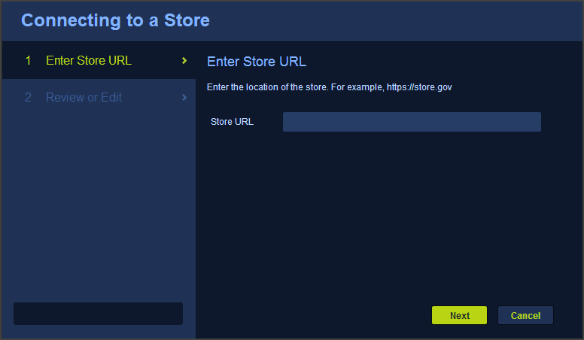
Figure 14: Store Configuration Wizard
To connect OWF to a Store:
- Open the OWF drop-down User Menu and click Administration.
- This opens the Administration Manager. Click Configuration to open the Configuration Console.
- From the left-hand panel, click Store.
- Click the Add Store button.
- This opens the Store Configuration window. Enter the Store’s URL and then, click Next (Figure 14). OWF will use the URL and automatically gather Store details.
- The Review or Edit page appears. Review or Edit the Store details:
  - Review the icon used to identify the Store to users in OWF
  - Add a name that will identity the Store to users in OWF
  - Click Save.
The Store button will appear on the OZONE Toolbar for all OZONE users (see below).
Note: If the Store button does not appear in the toolbar, refresh your browser window.
Figure 15: Store Button on OZONE Toolbar
Once a Store is configured, users can enter the Store to search, discover and add available listings including other OZONE Apps and App Components. Information on how to use the Store is covered in the Store User’s Guide.
    - Edit a Store
To edit a Store entry, repeat steps one through three from the previous section (4.6 : Connecting to the Store) to return to the Store configuration page. To edit a Store, hover over the Store name and click the pencil icon that appears to the right. This opens the Edit Store window, which is populated with the Store’s current information. Make changes to the fields, and then click Save.
    - Required Listings
A Store listing can require other Store listings. For example, if a user requests application component A and it requires application component B, the user automatically requests application components A and B. This relationship is further explained in the OWF User’s Guide.
When an application component, that requires other components, is added from the Store, the user will receive the application component along with all other application components that it needs.
In the App Components Manager, an administrator has two ways to identify that a Store application component requires other Store components.
- The details section of the listing will display: Requires App Component: true
- Its requirements will appear below the details
Both identifiers are highlighted in the following example:
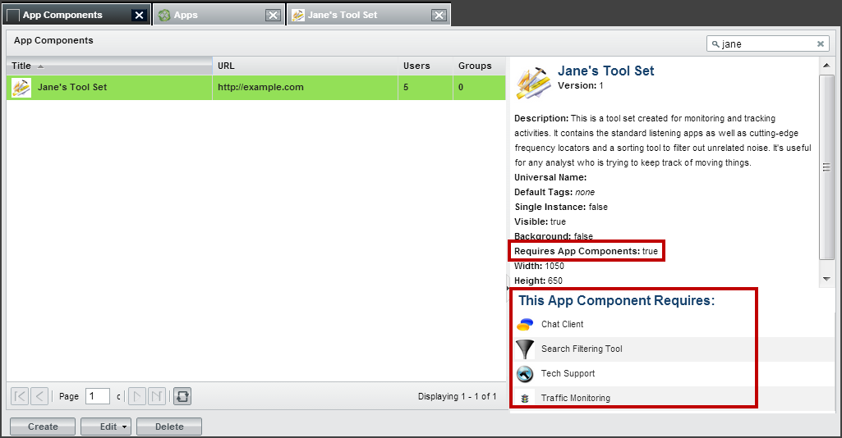
Figure 16: Required Application Component Identifiers
Required listings can only be added in the Store. For more information about adding or removing required listings, see the OZONE Store User’s Guide.

Known Issues

Browser Issues
Launching any of the Administration Editors (as well as many JavaScript-heavy apps) in certain versions of Internet Explorer consumes system memory that won’t be flushed or released until Internet Explorer is exited and restarted. Again, this is currently only an Internet Explorer issue.

User Interface Issues
Changes in screen resolution may render app components unviewable.
The positioning of the app components is absolute. This means that when changing from a larger monitor to a smaller monitor, or when changing from a higher screen resolution to a lower screen resolution, some floating windows may be either partially or fully off the viewable region of the screen. Currently there is no remedy for this issue.
Bundle Name / Version OWF-bundle-7.17.0.zip
OWF.WAR owf.war
Current Version OWF 7.17.0

